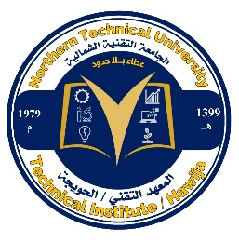
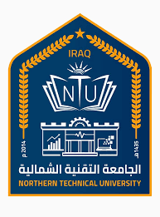
Northern Technical University / Al-Hawija Technical Institute/ Renewable Energy Research Center



personal information
Full name | Zeyad Khalaf Hamad Jikdum AL-jumely
The scientific title | Senior technical trainer
employment position | Researcher
Department | Renewable Energy Research Unit
Branch | Renewable Energy Research Unit
E-mail | zyadmech-haw@ntu.edu.iq

Academic certificates:
University | Academic certificate | date of the certificate | Specialization | Country
Northern Technical University | Diploma | 01/10/2009 | Mechanical techniques | iraq
Tikrit University | Bachelors | 28/10/2015 | Mechanical engineering sciences | iraq
Tikrit University | Masters | 27/03/2024 | Mechanical engineering sciences | iraq
- | Ph.D | - | - | -

Teaching experience
Teaching experience |  | The subject assigned to teach | Formation name
Undergraduate studies | YES | Metals laboratory, material properties, engineering workshops, welding metallurgy, AutoCAD laboratory | Al-Hawija Technical Institute
Graduate Studies | NO

Research and scientific activity
Published research | 2
Conferences and seminars | 0
Membership in scientific and professional societies and publishing houses
Profiles
 Google Scholar Profile | https://scholar.google.com/citations?hl=ar&user=Xl0CbkMAAAAJ
 Researcgate Profile | https://www.researchgate.net/profile/Zeyad-Hamad-4
 Publons Profile | https://www.webofscience.com/wos/author/record/KIB-1655-2024?edit=edit-profile
 ORCID iD | https://orcid.org/0009-0006-5430-7851
 Scopus | -------

Scientific and research interests: Mechanical engineering, heat transfer, refrigeration and air conditioning, , Renewable and Sustainable energies, green buildings, fuel and energy, combustion engines, Environment.
Honors and Awards
Issued by | Title of Achievement

