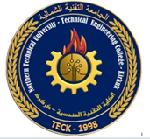

Northern Technical University / Kirkuk Engineering Technical College/ Architecture and Building Engineering Techniques
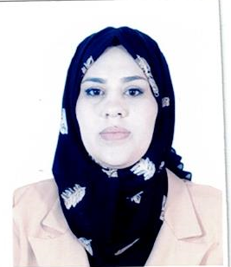

Personal information
Full name | Maha Adnan Muteab Mohammed
The scientific title | Assistant lecturer
employment position | Kirkuk Engineering Technical College
Department | Architecture and Building Engineering Techniques
Branch | -
E-mail | mahaadnan3@ntu.edu.iq

Academic certificates:
University | Academic certificate | date of the certificate | Specialization | Country
Tikrit University | Bachelor | 2013 | Civil Eng. | IRAQ
Tikrit University | M. Sc. | 2017 | Civil Eng./ Geo Techniques | IRAQ

Teaching experience
Undergraduate studies | YES
Postgraduate Studies | No

Research and scientific activity
Published researches | 2
Conferences and seminars | -
Membership in scientific and professional societies and publishing houses | -
Profiles
 Google Scholar Profile | https://scholar.google.com/citations?user=AwBdDsMAAAAJ&hl=en
 Researcgate Profile | https://www.researchgate.net/profile/Maha_Adnan2
 Publons Profile | https://www.webofscience.com/wos/author/record/LNP-4719-2024
 ORCID iD | http://orcid.org/0009-0007-3249-6935
 Scopus | https://www.scopus.com/authid/detail.uri?authorId=58164496700

Honours and Awards
Issued by | Title of Achievement
- | -

