
Northern Technical University

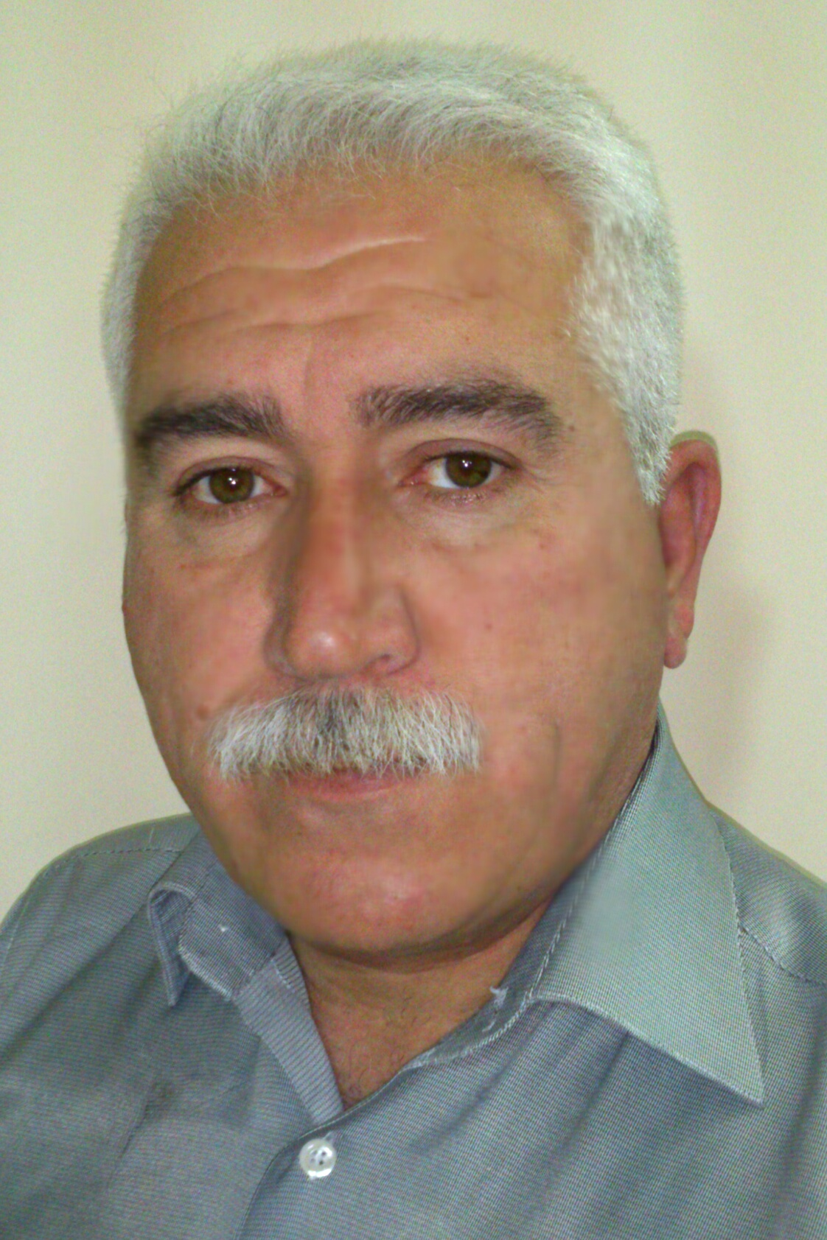

Personal information
Full name | Isam rafeeq faeq
Scientific title | Assistant Professor
employment position | Teaching
Department | Computer engineering techniques
Branch
E-mail | Essam_raffik@ntu.edu.iq

Academic Degrees
University | Academic Degree | date of the Degree | Specialization | Country
Salahaddin | Bachelors | 1984 | mathematics | Iraq
 | Higher Diploma | - | - | -
Al-Mustansiriya | Masters | 1990 | mathematics | Iraq
Al-Mustansiriya | Ph.D | 2007 | mathematics | Iraq

Teaching experience
Undergraduate studies | YES
Graduate Studies | YES

Research and scientific activity
Published researches 9 | Number of researches 8
Conferences and seminars | Number of conferences and seminars
Membership in scientific, professional societies and publishing houses
Profiles
 https://scholar.google.com/citations?hl=en&user=045XyNwAAAAJ#d=gs_hdr_drw&t=1706434093190

 https://www.researchgate.net/profile/Essam-Raffik

 Publons Profile

 https://orcid.org/0000-0003-2896-1447

 Scopus

Scientific and research interests:
Nonlinear partial differential equations

Honors and Awards:
Issued by | Title of Achievement

Last researches:

Research Title | Research Link
On the Butterfly Catastrophe Model and Stability of Finite Periodic Solutions for Some Non-Linear Differential Equations | https://kujss.uokirkuk.edu.iq/article_178277.html

