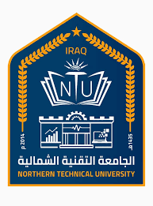
Northern Technical University

Personal information
Full name | Nadia Talib Nori Al Jawady
Scientific title | Teacher
employment position | department rapporteur
Department | Electronic management
Branch | --------
E-mail | NadiaTalib@ntu.edu.iq

Academic Degrees:
University | Academic Degree | date of the Degree | Specialization | Country
University of Mosul | Bachelors | 1992-1993 | Physical education and sports sciences | Iraq
University of Mosul | Masters | 2007-2008 | Sports biomechanics | Iraq
University of Mosul | Ph.D | 2020-2021 | Sports psychology | Iraq

Teaching experience
Undergraduate studies | 6
Graduate Studies | NO

Research and scientific activity
Published researches | 9
Conferences and seminars | 5
Membership in scientific and professional societies and publishing houses | NO
 Google Scholar Profile | https://scholar.google.com/citations?user=mnvYvBkAAAAJ&hl=ar
 Researcgate Profile | https://www.researchgate.net/profile/Nadia-Al-Jawady
 Publons Profile | https://publons.com/dashboard/records/publication/import/?show_wos_rid_cta=True
 ORCID iD | https://orcid.org/0000-0002-4965-3235
 Scopus | https://www.scopus.com/search/form.uri?display=basic#basic
https://researchid.co/

Scientific and research interests: Sports psychology

Honors and Awards
Issued by | Title of Achievement
----------- | NO

