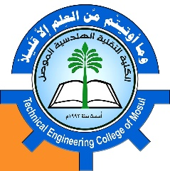
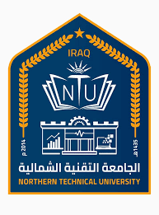
Northern Technical University / Technical Engineering college of Mosul / department

Personal information
Full name | Banan najim aldeen abdalla
Scientific title | Assist. Lecturer
employment position | University Instructor
Department | Power Mechanics Techniques Engineering
Branch
E-mail | Banan.najim@ntu.edu.iq

Academic Degrees:
University | Academic Degree | date of the Degree | Specialization | Country
Mosul | Bachelors | 2002 | Mechanical Engineering | Iraq
 | Higher Diploma | - | - | -
Mosul | Masters | 2020 | Thermal Eng. Techniques | Iraq
Technology | - | - | - | -

Teaching experience
Undergraduate studies | YES
Graduate Studies | YES

Research and scientific activity
Published researches | 3
Conferences and seminars
Membership in scientific and professional societies and publishing houses
Profiles
 Google Scholar Profile | https://scholar.google.com/citations?hl=ar&user=Sdk9OtAAAAAJ&view_op=list_works&gmla=AJsN-F7Rscr3gxFHiT-xzDAhIVbO7rbip8PiUPbspaC1LvfR0mF_5Uc1DXAULSecHwdOSiFBOI1rAKW8jGv8F4tauZNptmziPj9XZgoZUEKC7798VPKIGPTnE-0It0ffE9gDo0zXgGyZ
 Researcgate Profile | https://www.researchgate.net/profile/Omar-Sadoon-2
 Publons Profile | https://www.webofscience.com/wos/author/record/GRO-3843-2022
 ORCID iD | https://orcid.org/my-orcid?orcid=0000-0003-0430-8961
 Scopus | https://www.scopus.com/authid/detail.uri?authorId=58110515300

Scientific and research interests:
heat transfer, nanofluid, energy
Honors and Awards
Issued by | Title of Achievement

